**Date:03/02/2002**

**SQL Assignment 1**

create database Northwind

create table Products

(

ProductID int NOT NULL Primary key,

ProductName varchar(40) NOT NULL,

SupplierID int NOT NULL,

CategoryID int NOT NULL,

QuantityPerUnit varchar(20) NOT NULL,

UnitPrice decimal(10,4) NOT NULL,

UnitsInStock smallint NOT NULL,

UnitsOnOrder smallint NOT NULL,

ReorderLevel smallint NOT NULL,

Discontinued bit NOT NULL

)

insert into Products VALUES('1', 'Chai','1','1','10 cups', '10' , '27' , '0' , '10' , '0')

insert into Products VALUES('2', 'Coffee','1','1','20 cups', '30' , '45' , '10' ,'15' ,'0')

insert into Products VALUES('3', 'Mocktail','2','1','5 glasses', '70' , '20' , '3' ,'5' ,'1')

insert into Products VALUES('4', 'cold coco','2','1','10 glasses','110' , '30' ,'7' ,'13' ,'0')

insert into Products VALUES('5', 'Kitkat Shake','3','2','20 glasses','150' ,'25' ,'0' ,'5' ,'0')

insert into Products VALUES('6', 'manchow soup','4','3','5 bowls','80' , '20' ,'3' ,'7' ,'1')

insert into Products VALUES('7', 'veg soup','4','3','5 bowls','60' , '40' ,'10' ,'5' ,'1')

insert into Products VALUES('8', 'chocolate','2','1','50 pieces','30' , '300' ,'100' ,'50' ,'0')

insert into Products VALUES('9', 'candy','3','4','40 pieces','35' , '100' ,'10' ,'30' ,'0')

insert into Products values('10','Green tea','1','1','20 cups','20','50','0','10','0')

insert into Products values('11','Water bottle','1','1','20 bottles','15','50','0','10','0')

insert into Products values('12','Fanta','1','1','20 bottles','20','10','30','5','0')

**1.** **Write a query to get a Product list (id, name, unit price) where current products cost less than $20.**

select ProductID, ProductName,UnitPrice from Products where ((UnitPrice < 20) AND Discontinued = 0 )

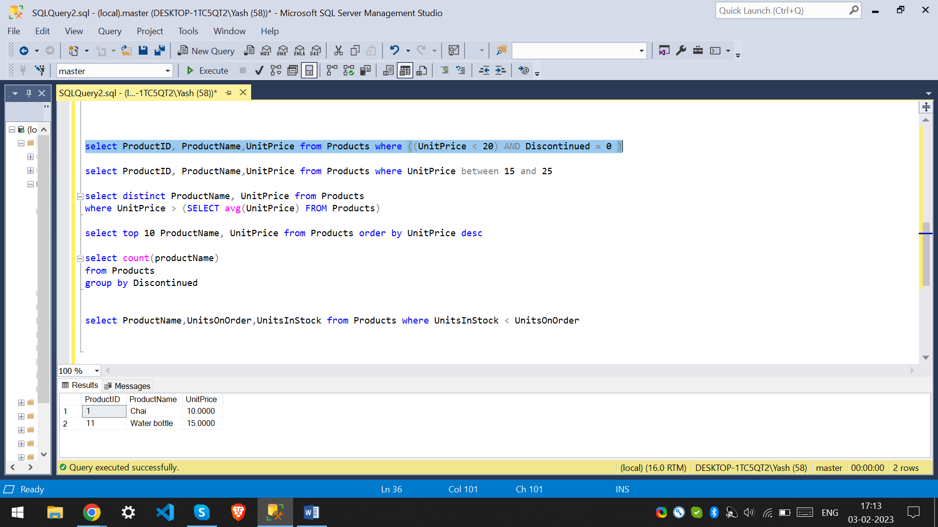

**2. Write a query to get Product list (id, name, unit price) where products cost between $15 and $25**

select ProductID, ProductName,UnitPrice from Products where UnitPrice between 15 and 25

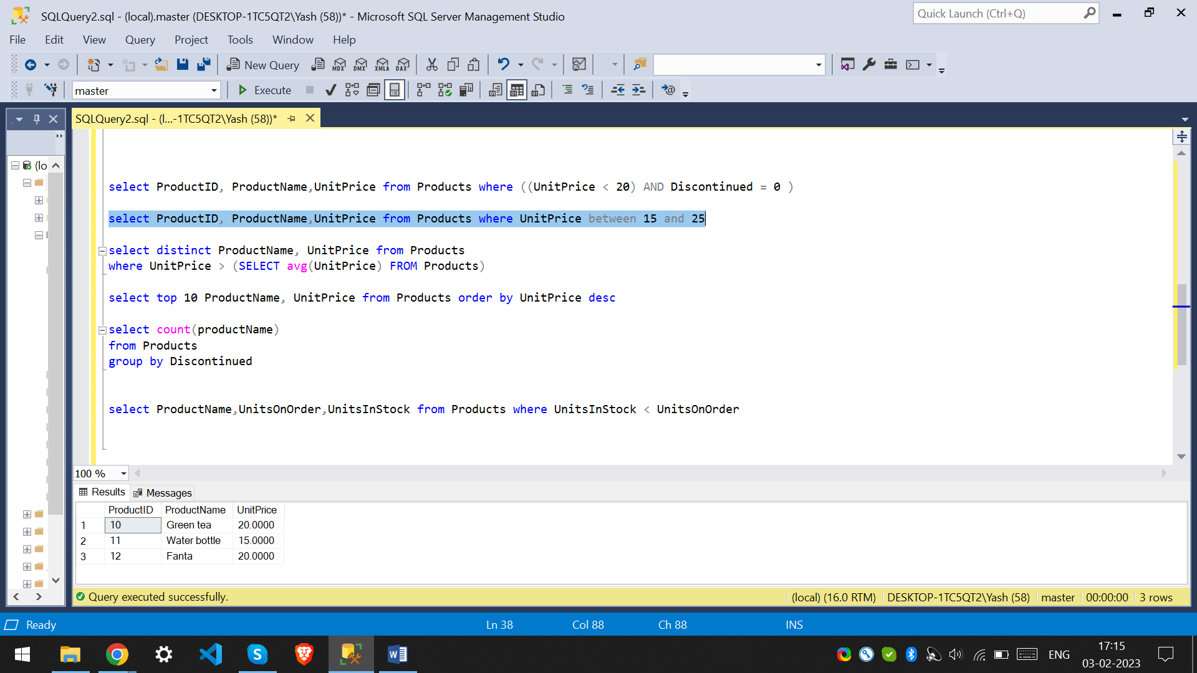

**3.** **Write a query to get Product list (name, unit price) of above average price.**

select distinct ProductName, UnitPrice from Products

where UnitPrice > (SELECT avg(UnitPrice) FROM Products)

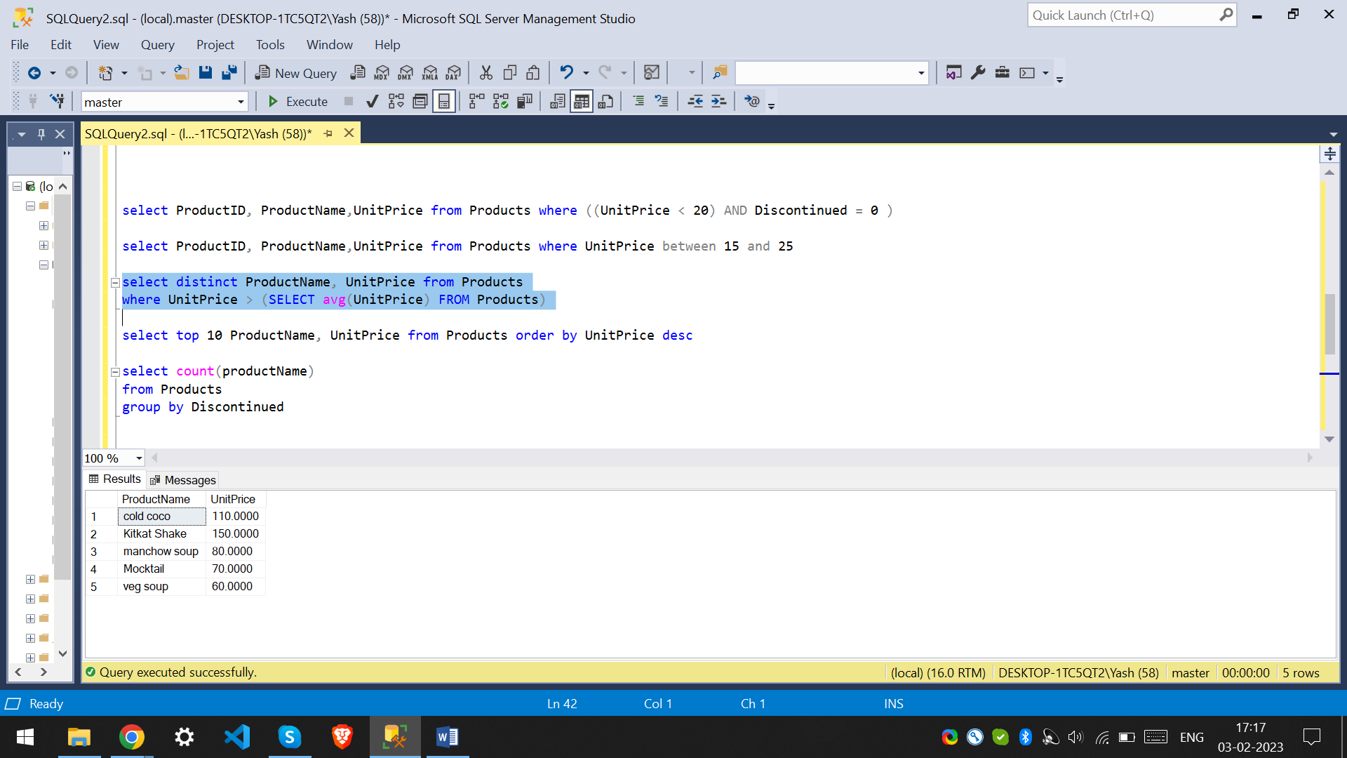

**4.** **Write a query to get Product list (name, unit price) of ten most expensive products**

select top 10 ProductName, UnitPrice from Products order by UnitPrice desc

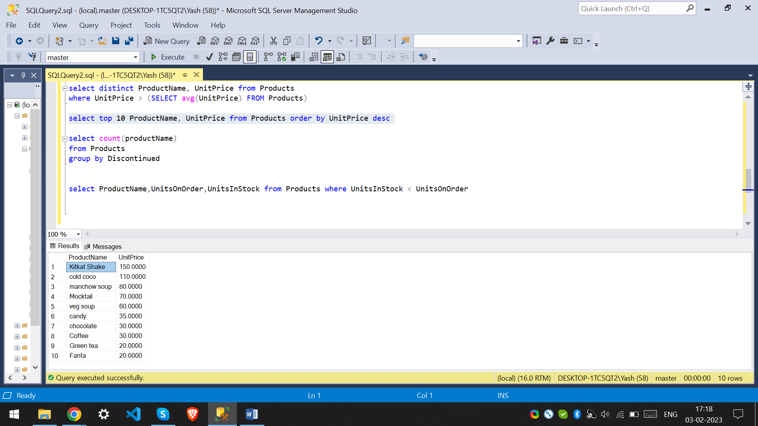

**5.** **Write a query to count current and discontinued products**

select count(productName) from Products group by Discontinued

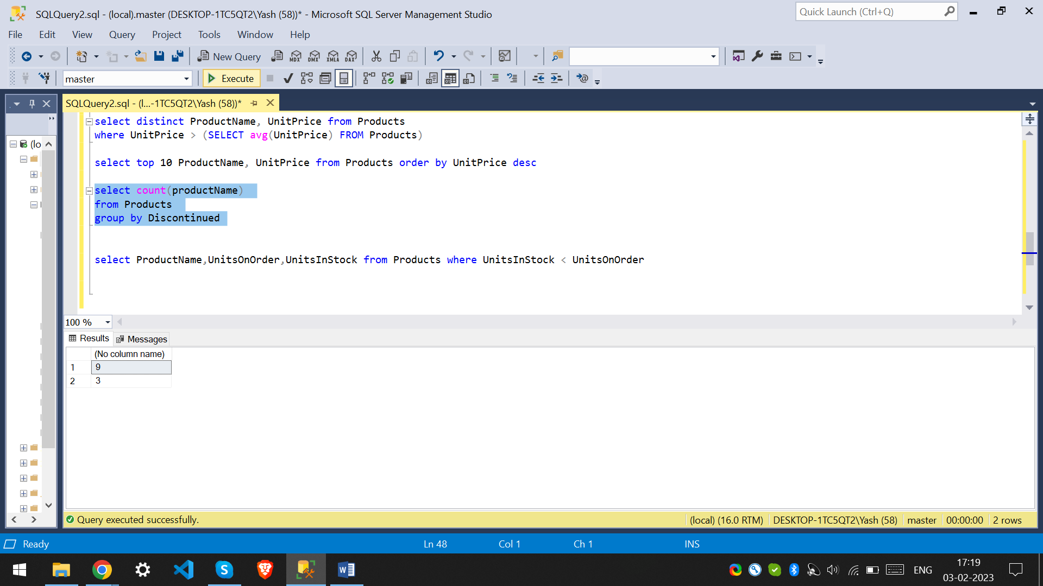

**6.** **Write a query to get Product list (name, units on order , units in stock) of stock is less than the quantity on order**

select ProductName,UnitsOnOrder,UnitsInStock from Products where UnitsInStock < UnitsOnOrder

